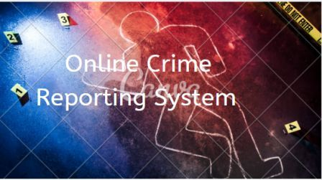

A project report on
“Online Crime Reporting System”

CE714 - Project
Submitted by
- Dipali Tank, 20SOECE13055.
- Divya Rana, 20SOECE13048.
- Bansi Nanda, 20SOECE13019.

In partial fulfillment for the award of the Degree of
BACHELOR OF TECHNOLOGY
IN
COMPUTER ENGINEERING



SCHOOL OF ENGINEERING,
RK UNIVERSITY,
RAJKOT, GUJARAT-360020
October-2022

PROJECT APPROVAL
This is to certify that project work embodied in this entitled: “Online Crime Reporting System” was carried out by Dipali Tank (20SOECE13055), Divya Rana (20SOECE13048), Bansi Nanda (20SOECE13019) at Department of Computer Engineering, School of Engineering, RK University is approved for award of the degree of B.Tech by RK University.

Date: 20-10-2022
Place: Rajkot

Examiner(s) Name and Signature:

TABLE OF CONTENT

1.0 Introduction
1.1 Characteristics of Existing System
1.2 Overview of Proposed System
1.3 Scope (Scope – List of Modules and their Functions)
1.4 Process Model – (Describe the process model with Reason.)

2.0 System Requirements Specification
2.1 User Characteristics (Type of users who is dealing with the system and their roles)
2.2 Functional Requirements (Describe each module and its functionalities)
2.3 Non-Functional Requirements

3.0 System Analysis Modeling – User-based
3.1 Feasibility Study of the New System – Here you have to discuss the following
Feasibilities: Technical Feasibility, Time Feasibility, and Cost Feasibility.

4.0 System Analysis and Design – Data-based
4.1 Data Modelling
4.1.1 Data Dictionary (List of Database Tables included in the system)
4.2 Behavioral Modelling
4.2.1 Data Flow Diagram
4.2.1.1 Context Level Diagram (Level 0)
4.2.1.2 DFD – Level 1
4.2.1.3 DFD – Level 2

5.0 Software and Hardware requirements

6.0 Sample Coding/Code Templates

7.0 System Interface Design
7.1 User Interface Design
7.2 Output Design

8.0 Testing

9.0 Limitions of the system

10.0 Future scope of the system

11.0 References

Online Crime Reporting System

ABSTRACT

We all know that nowadays crime rate is frequently increasing day by day in our society. From this we get an idea to develop the system.

Problem was that people got tired by going here and there for getting justice.

So our application is capable of registering FIR online, shows investigation update, deliver news about crime etc. So it is an application which provide solution to the problems faced during taking actions against crime.

CHAPTER-1.0
INTRODUCTION

1.1 Characteristics of existing system.
1.2Overview of advanced system
1.3Scope
1.4Process Model

INTRODUCTION:-

Characteristics of existing system:-

It tracks all the information of Criminal, Complaint, Solutions etc. Manage the information of Criminal. Shows the information and description of the Crime, Public. All the fields such as Crime, Public, Department are validated and does not take invalid values.

Overview of advanced system:-

We have developed the portal of “CRIME REPORTING”, the portal can handle data the criminals who are under the judicial surveillance or are under trial. This portal will be most useful for defense for searching of details of crimes. Anyone can report a crimes online, missing person, vehicle and things secure registration and profile management facilities, reduce the work of policy and user and reduce the time.

Scope:
This website provides an architectural overview of the crime management. This website is a generic. Web-based tool that enables user to manage the crime on tasks completed as part of project with tasks and sub-tasks. The tool includes interactivity, Functionality,Information will be stored in to a database. Administrative and managerial functions will be provide including configuration projects/tasks/subtasks.

Process Model:-
Software Development Life Cycle Software Development Life Cycle, SDLC for short, is a well-defined, structured
Sequence of stages in software engineering to develop the intended software product.

SDLC Activities:-
SDLC provides a series of steps to be followed to design and develop a software product efficiently. SDLC framework includes the following steps:

• Communication
• Requirement Gathering
• Feasibility Study
• System Analysis
• Software Design
• Coding
• Testing
• Implementation
• Integration
• Operations & Maintenance

1. Communication:-
This is the first step where the user initiates the request for a desired software product. He contacts the service provider and tries to negotiate the terms. He submits his request to the service providing organization in writing.

2. Requirement Gathering:-
This step onwards, the software development team works to carry on the project. The team holds discussions with various stakeholders from problem domain and tries to bring out as much information as possible on their requirements. The requirements are contemplated and segregated into user requirements, system requirements and functional requirements. The requirements are collected using a number of practices as given -
• Studying the existing or obsolete system and software
• Conducting interviews of users and developers
• Referring to the database or
• Collecting answers from the questionnaires.

3. Feasibility Study:-
A feasibility study is undertaken to determine the possibility or probability of either improving the existing system or developing a completely new system.
A feasibility study is defined as an evaluation or analysis of the potential impact of a proposed project. Feasibility study is conducted once the problem is clearly understood. Feasibility study is a high level capsule version of the entire system analysis and design process. The objective is to determine quickly at a minimum expense how to solve a problem. The purpose of feasibility is not to solve the problem but to determine if the problem is worth solving. Feasibility and risk analysis are related in many ways. If project risk is huge, the feasibility of producing quality software is reduced. During product engineering, however,
we concentrate our attention on following primary areas of interest.

4. System Analysis:-
At this step the developers decide a roadmap of their plan and try to bring up the
best software model suitable for the project. System analysis includes understanding of software product limitations, learning system related problems or changes to be done in existing systems beforehand, identifying and addressing the impact of project on organization and personnel etc. The project team analyzes the scope of the project and plans the schedule and resources accordingly.

5. Software Design:-
Next step is to bring down whole knowledge of requirements and analysis on the desk and design the software product. The inputs from users and information gathered in requirement gathering phase are the inputs of this step. The output of this step comes in the form of two designs: logical design and physical design. Engineers produce meta-data and data dictionaries, logical diagrams, data-flow diagrams and in some cases pseudo codes.

6. Coding:-
This step is also known as programming phase. The implementation of software design starts in terms of writing program code in the suitable programming language and developing error-free executable programs efficiently.

7. Testing:-
An estimate says that 50% of whole software development process should be tested. Errors may ruin the software from critical level to its own removal. Software testing is done while coding by the developers and thorough testing is conducted by testing experts at various levels of code such as module testing, program testing, product testing, in-house testing and testing the product at user’s end. Early discovery of errors and their remedy is the key to reliable software.

8. Implementation:-
This means installing the software on user machines. At times, software needs postinstallation configurations at user end. Software is tested for portability and adaptability and integration related issues are solved during implementation.

9. Integration:-
Software may need to be integrated with the libraries, databases and other program. This stage of SDLC is involved in the integration of software with outer world entities.

10. Operation and Maintenance:-
This phase confirms the software operation in terms of more efficiency and less errors. If required, the users are trained on, or aided with the documentation on how to operate the software and how to keep the software operational. The software is maintained timely by updating the code according to the changes taking place in user end environment or technology. This phase may face challenges from hidden bugs and real-world unidentified problems.

SDLC- Iterative Incremental Model

In an Iterative Incremental model, initially, a partial implementation of a total system is constructed so that it will be in a deliverable state. Increased functionality is added. Defects, if any, from the prior delivery are fixed and the working product is c. The process is repeated until the entire product development is completed. The repetitions of these processes are called iterations. At the end of every iteration, a product increment is delivered.

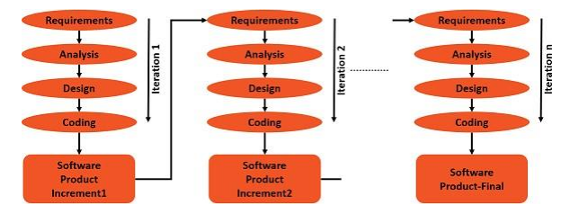

Iterative Incremental Model – Strengths
The advantages or strengths of Iterative Incremental model are −
• You can develop prioritized requirements first.
• Initial product delivery is faster.
• Customers get important functionality early.
• Lowers initial delivery cost.
• Each release is a product increment, so that the customer will have a working product at hand all the time.
• Customer can provide feedback to each product increment, thus avoiding surprises at the end of development.
• Requirements changes can be easily accommodated

Iterative Incremental Model – Weaknesses
The disadvantages of the Iterative Incremental model are-
• Requires effective planning of iterations.
• Requires efficient design to ensure inclusion of the required functionality and provision for changes later.
• Requires early definition of a complete and fully functional system to allow the definition of increments.
• Well-defined module interfaces are required, as some are developed long before others are developed.
• Total cost of the complete system is not lower

When to Use Iterative Incremental Model?
Iterative Incremental model can be used when −
• Most of the requirements are known up-front but are expected to evolve over time.
• The requirements are prioritized.
• There is a need to get the basic functionality delivered fast.
• A project has lengthy development schedules.
• A project has new technology.
• The domain is new to the team.

CHAPTER-2.0
SYSTEM REQUIREMENTS
SPECIFICATION

2.1User characteristics
2.2Functional requirements
2.3Non functional requirements

Software Requirements Specification:

User characteristics:-

The user can send photo evidence if any online. The police will have a criminal database through which they can access the records anytime. In this system, user's information will be kept confidential and only users complain will be forwarded to the nearest police station.

Functional requirements:-

Registration:-
Users need to be registered in the clinic management system so as to use the system and add the criminals’ details, add complaints, update closed cases, etc. If the user is not registered in the prison management system, he/she cannot do any task with it like writing FIRs, adding prisoner crime and punishment details, etc.

Login:-
After registration one can log in to the system as the operator of the system on the behalf of the user. After this, he has the other user interfaces available for further actions.

Complain History:-
The registered user user can add the desired complain into his cart by clicking add to cart option on the product. He can view his cart by clicking on the cart button. All products added by cart can be viewed in the cart. The registered user can remove an item from the cart by clicking remove. After confirming the items in the cart the The registered user can submit the cart by providing a delivery address. On successful submitting the cart will become empty.
– System must ensure that, only a registered customer can purchase items.
Admin:-
Manage The registered user:-
The administrator can add The registered user, delete The registered user, view The registered user.
Manage Police Station:-
The administrator can add product, delete product, hide product and view product.
Manage Updating:-
The administrator can view orders and update complaint status.
-ONLINE CRIME REPORTING SYSTEM must identify the login of the admin.

Non functional requirements:-

Efficiency Requirement:-
When an online CRIME REPORTING SYSTEM OF POLICE STATION implemented The registered user can create complaint in an efficient manner.

Reliability Requirement:-
ONLINE CRIME REPORTING SYSTEM should provide a reliable environment to both The registered users and administrator . All complaint should be reaching at the admin end without any errors.

Usability Requirement:-
ONLINE CRIME REPORTING SYSTEM is designed for The registered user friendly environment and ease of user.

Implementation Requirement:-
Implementation of ONLINE CRIME REPORTING SYSTEM using CSS, AJAX and html in front end with PHP as back end and it will be used for database connectivity. And the database part is developed by Xampp. Responsive web designing is used for making the website compatible for any type of screen.
Delivery Requirement:-
The whole system is expected to be delivered in 6 months of time with weekly evaluation by the project guide.

Database Security:-
Unauthorized person cannot access the panel and database, do not read and write the information.

Availability:-
ONLINE CRIME REPORTING SYSTEM will be available Monday-Friday(24-Hours),Saturday (24-Hour) and Sunday 4.30am-12.00am.

CHAPTER - 3.0
System Analysis Modeling – User-based

3.1 Feasibility Study of the New System

System analysis and modeling- User based:-

Feasibility study of the new system:-
A feasibility study assesses the operational, technical and economic merits of the
proposed project. The feasibility study is intended to be a preliminary review of the facts to see if it is worthy of proceeding to the analysis phase. From the systems analyst perspective, the feasibility analysis is the primary tool for recommending whether to proceed to the next phase or to discontinue the project.
The feasibility study is a management-oriented activity. The objective of a feasibility study is to find out if an information system project can be done and to suggest possible alternative solutions.
Projects are initiated for two broad reasons:
1. Problems that lend themselves to system solutions
2. Opportunities for improving through:
a. Upgrading systems
b. Altering systems
c. Installing new systems
A feasibility study should provide management with enough information to decide:
o Whether the project can be done?
o Whether the final product will benefit its intended users and organization?
o What are the alternatives among which a solution will be chosen?
o Is there a preferred alternative?

➢ Types of feasibility:-
i. Technical feasibility
ii. Economic feasibility
iii. Operational feasibility

1. Technical Feasibility:-
A large part of determining resources has to do with assessing technical feasibility. It considers the technical requirements of the proposed project. The technical requirements are then compared to the technical capability of the organization. The systems project is considered technically feasible if the internal technical capability is sufficient to support the project requirements.
The analyst must find out whether current technical resources can be upgraded to in a manner that fulfils the request under consideration. This is where the expertise of system analysts is beneficial, since using their own experience and their contact with vendors; they will be able to answer the question of technical feasibility.
The essential questions that help in testing the operational feasibility of a system
Include the following:
• Is the project feasible within the limits of current technology?
• Does the technology exist at all?
• Is it available within gives resource constraints?
• Is it a practical proposition?
• Manpower – programmers, testers & debuggers
• Software and hardware
• Are the current technical resources sufficient for the new system?
• Can they be upgraded to provide the level of technology necessary for the new system?
• Do we possess the necessary technical expertise, and is the schedule reasonable?
• Can the technology be easily applied to current problems?
• Does the technology have the capacity to handle the solution?
• Do we currently possess the necessary technology?

2. Operational Feasibility:-
Operational feasibility is dependent on human resources available for the project and involves projecting whether the system will be used if it is developed and implemented. The operational feasibility assessment focuses on the degree to which the proposed development projects fit in with the existing business environment and objectives with regard to development schedule, delivery date, corporate culture and existing business processes. To ensure success, desired operational outcomes must be imparted during design and development. These include design-dependent parameters such as reliability, maintainability, supportability, usability, predictability, disposability, sustainability, affordability and others. These parameters are required to be considered at the early stages of design if desired operational behaviors’ are to be realized. A system design and development requires appropriate and timely application of engineering and management efforts to meet the previously mentioned parameters. A system may serve its intended purpose most effectively when its technical and operating characteristics are engineered into the design. Therefore, operational feasibility is a critical aspect of systems engineering that needs to be an integral part of the early design phases. The essential questions that help in testing the operational feasibility of a system include the following:
o Does current mode of operation provide adequate throughput and response time?
o Does current mode provide end users and managers with timely, pertinent, accurate and
useful formatted information?
o Does current mode of operation provide cost-effective information services to the business?
o Could there be a reduction in cost and/or an increase in benefits?
o Does current mode of operation offer effective controls to protect against fraud and to guarantee accuracy and security of data and information?

3. Economic Feasibility:-
The purpose of the economic feasibility assessment is to determine the positive
Economic benefits to the organization that the proposed system will provide. It includes identification of all the benefits expected. This assessment typically involves a cost/ benefits analysis.
Economic analysis could also be referred to as cost/benefit analysis. It is the most
frequently used method for evaluating the effectiveness of a new system. In economic analysis, the procedure is to determine the benefits and savings that are expected from a candidate system and compare them with costs. If benefits outweigh costs, then the decision is made to design and implement the system. An entrepreneur must accurately weigh the cost versus benefits before taking an action.
Possible questions raised in economic analysis are:
• Is the system cost effective?
• Do benefits outweigh costs?
• The cost of doing full system study
• The cost of business employee time
• Estimated cost of hardware
• Estimated cost of hardware/software development
• Is the project possible, given the resource constraints?
• What are the savings that will result from the system?
• Cost of employees' time for study
• Cost of packaged hardware/software development
• Selection among alternative financing arrangements
The concerned business must be able to see the value of the investment it is pondering before committing to an entire system study. If short-term costs are not overshadowed by long-term gains or produce no immediate reduction in operating costs, then the system is not economically feasible, and the project should not proceed Any further. If the expected benefits equal or exceed costs, the system can be judged to be economically feasible. Economic analysis is used for evaluating the effectiveness of the proposed system.
The economic feasibility will review the expected costs to see if they are in-line with the projected budget or if the project has an acceptable return on investment. At this point, the projected costs will only be a rough estimate. The exact costs are not required to determine economic feasibility. It is only required to determine if it is feasible that the project costs will fall within the target budget or return on investment. A rough estimate of the project schedule is required to determine if it would be feasible to complete the system’s project within a required timeframe. The required timeframe would need to be set by the organization.

CHAPTER-4.0
SYSTEM ANALYSIS AND DESIGNDATA-BASED

4.1Data modeling
4.1.1 Data dictionary
4.1.2 E-R diagram
4.2 Behavioral Modeling
4.2.1 Data flow diagram
4.2.1.1 Context Level Diagram (Level 0)
4.2.1.2 DFD-Level 1

System Analysis and Design- Data base:
- Data modeling:
- -Data dictionary:-

User:-
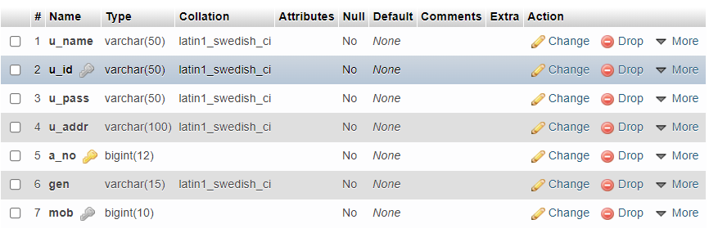

police_station:-
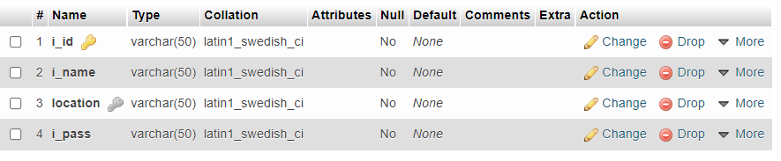

Police:-
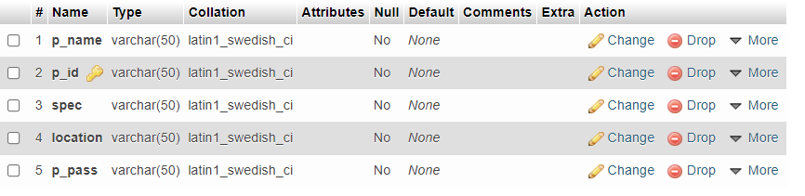

Complaint:-
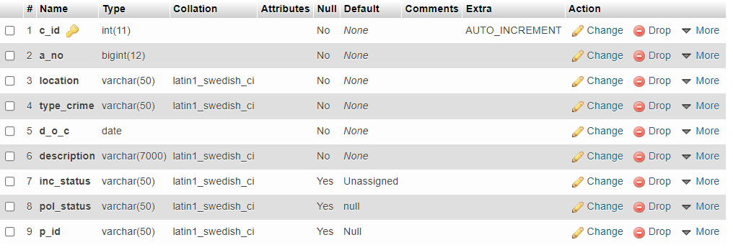

Head:-
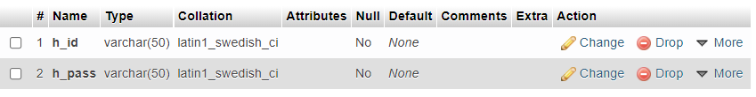

update_case:-
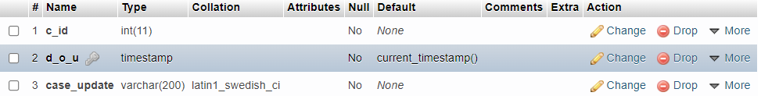

E-R (Entity Relationship) Diagram:-
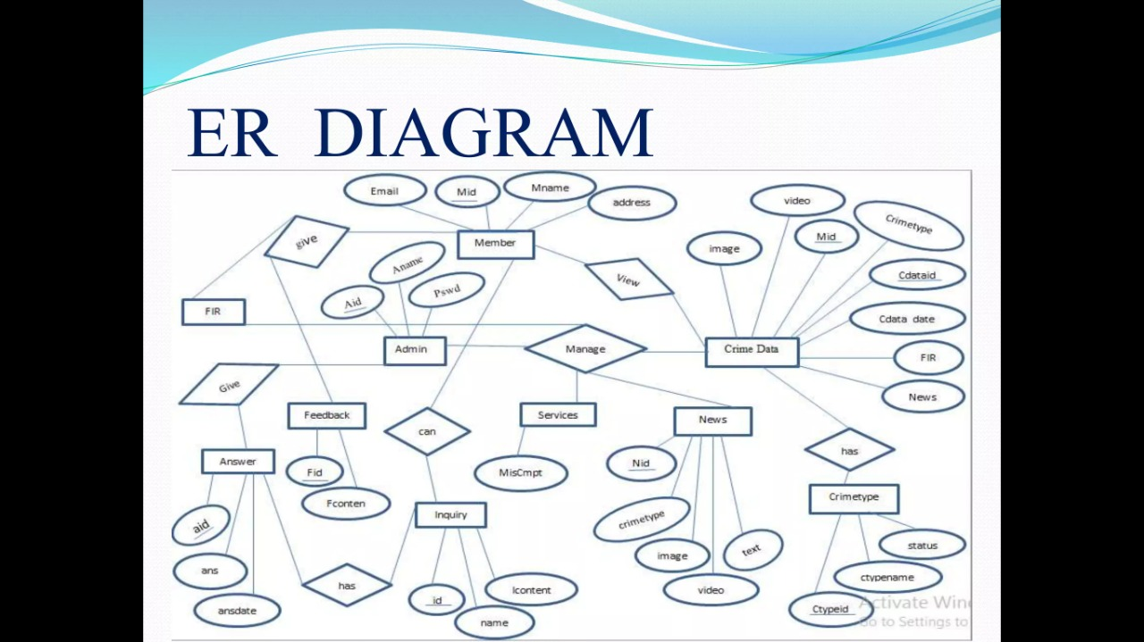

Behavioural modeling:-
• Data flow diagram:-
Context Level Diagram (Level 0)

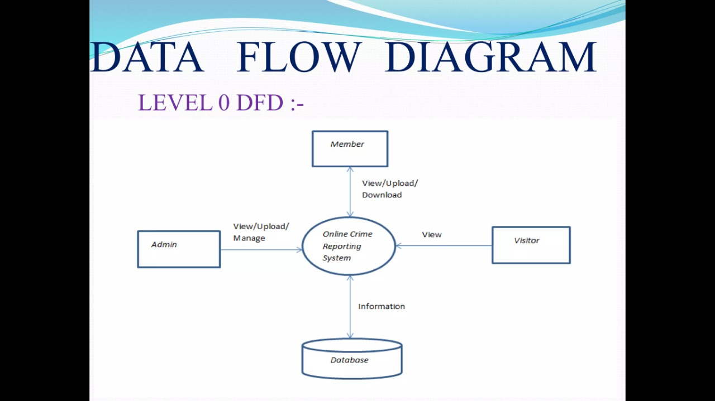

DFD level-1

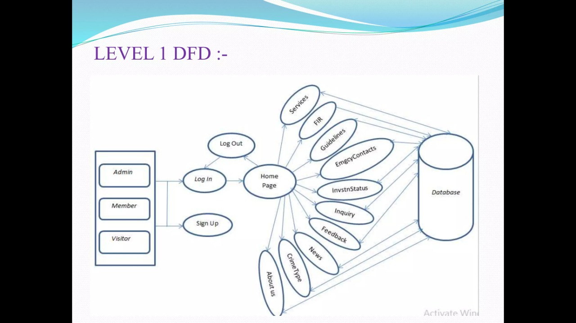

DFD level-2
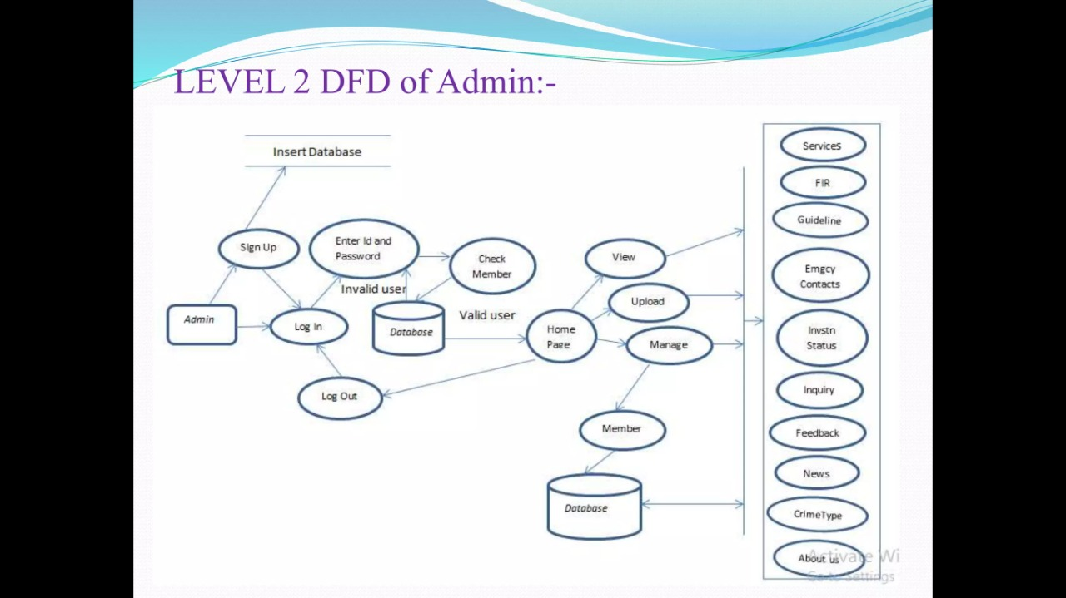

CHAPTER-5.0
SOFTWARE AND HARDWARE
REQUIREMENTS

SOFTWARE AND HARDWARE REQUIREMENTS

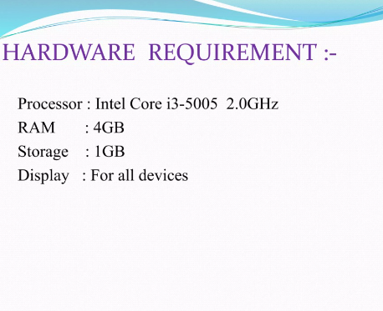

CHAPTER-6.0
SAMPLE CODING/CODE TEMPLATES

Incharge_complain_details.php

<!DOCTYPE html>
<html>
<head>

<?php
session_start();
if(!isset($_SESSION['x']))
header("location:inchargelogin.php");

$conn=mysqli_connect("localhost","root","","crime_portal");
if(!$conn)
{
die("could not connect".mysqli_error());
}
mysqli_select_db("crime_portal",$conn);

$cid=$_SESSION['cid'];

$i_id=$_SESSION['email'];
$result1=mysqli_query("SELECT location FROM police_station where i_id='$i_id'",$conn);
$q2=mysqli_fetch_assoc($result1);
$location=$q2['location'];

$query="select c_id,type_crime,d_o_c,description from complaint where c_id='$cid' and location='$location' order by c_id desc";
$result=mysqli_query($query,$conn);
$res2=mysqli_query("select d_o_u,case_update from update_case where c_id='$cid'",$conn);
?>

<title>Incharge Homepage</title>
<link rel="stylesheet" type="text/css" href="https://maxcdn.bootstrapcdn.com/bootstrap/3.3.5/css/bootstrap.min.css">
<link rel="stylesheet" type="text/css" href="https://maxcdn.bootstrapcdn.com/font-awesome/4.4.0/css/font-awesome.min.css">
<link href="http://fonts.googleapis.com/css?family=Lato:300,400,700,300italic,400italic,700italic" rel="stylesheet" type="text/css">
</head>
<body>
<nav class="navbar navbar-default navbar-fixed-top">
<div class="container">
<div class="navbar-header">
<button type="button" class="navbar-toggle collapsed" data-toggle="collapse" data-target="#navbar" aria-expanded="false" aria-controls="navbar">
<span class="sr-only">Toggle navigation</span>
<span class="icon-bar"></span>
<span class="icon-bar"></span>
<span class="icon-bar"></span>
</button>
<a class="navbar-brand" href="home.php"><b>Crime Portal</b></a>
</div>
<div id="navbar" class="collapse navbar-collapse">

<ul class="nav navbar-nav navbar-right">
<li ><a href="Incharge_complain_page.php">View Complaints</a></li>
<li class="active" ><a href="incharge_complain_details.php">Complaints Details</a></li>
<li><a href="inc_logout.php">Logout &nbsp <i class="fa fa-sign-out" aria-hidden="true"></i></a></li>
</ul>
</div>
</div>
</nav>

<div style="padding:50px; margin-top:10px;">
<table class="table table-bordered">
<thead class="thead-dark" style="background-color: black; color: white;">
<tr>
<th scope="col">Complaint Id</th>
<th scope="col">Type of Crime</th>
<th scope="col">Date of Crime</th>
<th scope="col">Description</th>
</tr>
</thead>
<?php
while($rows=mysqli_fetch_assoc($result)){
?>
<tbody style="background-color: white; color: black;">
<tr>

<td><?php echo $rows['c_id']; ?></td>
<td><?php echo $rows['type_crime']; ?></td>
<td><?php echo $rows['d_o_c']; ?></td>
<td><?php echo $rows['description']; ?></td>
</tr>
</tbody>
<?php
}
?>
</table>
</div>

<div style="padding:50px; margin-top:8px;">
<table class="table table-bordered">
<thead class="thead-dark" style="background-color: black; color: white;">
<tr>
<th scope="col">Date Of Update</th>
<th scope="col">Case Update</th>
</tr>
</thead>
<?php
while($rows1=mysqli_fetch_assoc($res2)){
?>
<tbody style="background-color: white; color: black;">
<tr>

<td><?php echo $rows1['d_o_u']; ?></td>
<td><?php echo $rows1['case_update']; ?></td>

</tr>
</tbody>
<?php
}
?>

</table>
</div>

<div style="position: fixed;
left: 0;
bottom: 0;
width: 100%;
height: 30px;
background-color: rgba(0,0,0,0.8);
color: white;
text-align: center;">
<h4 style="color: white;">&copy <b>Crime Portal 2018</b></h4>
</div>

<script type="text/javascript" src="https://code.jquery.com/jquery-2.1.4.js"></script>
<script type="text/javascript" src="https://maxcdn.bootstrapcdn.com/bootstrap/3.3.5/js/bootstrap.min.js"></script>
</body>
</html>

<!DOCTYPE html>
<html>
<head>

<?php
session_start();
if(!isset($_SESSION['x']))
header("location:inchargelogin.php");

$conn=mysqli_connect("localhost","root","","crime_portal");
if(!$conn)
{
die("could not connect".mysqli_error());
}
mysqli_select_db("crime_portal",$conn);

$cid=$_SESSION['cid'];

$i_id=$_SESSION['email'];
$result1=mysqli_query("SELECT location FROM police_station where i_id='$i_id'",$conn);

$q2=mysqli_fetch_assoc($result1);
$location=$q2['location'];

$query="select c_id,type_crime,d_o_c,description from complaint where c_id='$cid' and location='$location'";
$result=mysqli_query($query,$conn);
if(isset($_POST['assign']))
{
if($_SERVER["REQUEST_METHOD"]=="POST")
{
$pname=$_POST['police_name'];
$res1=mysqli_query("SELECT p_id FROM police where p_name='$pname'",$conn);
$q3=mysqli_fetch_assoc($res1);
$pid=$q3['p_id'];

$res=mysqli_query("update complaint set inc_status='Assigned',pol_status='In Process',p_id='$pid' where c_id='$cid'",$conn);

$message = "Case Assigned Successfully";
echo "<script type='text/javascript'>alert('$message');</script>";
}
}
?>

<title>Assign Police</title>
<link rel="stylesheet" type="text/css" href="https://maxcdn.bootstrapcdn.com/bootstrap/3.3.5/css/bootstrap.min.css">
<link rel="stylesheet" type="text/css" href="https://maxcdn.bootstrapcdn.com/font-awesome/4.4.0/css/font-awesome.min.css">
<link href="http://fonts.googleapis.com/css?family=Lato:300,400,700,300italic,400italic,700italic" rel="stylesheet" type="text/css">

</head>
<body>
<nav class="navbar navbar-default navbar-fixed-top">
<div class="container">
<div class="navbar-header">
<button type="button" class="navbar-toggle collapsed" data-toggle="collapse" data-target="#navbar" aria-expanded="false" aria-controls="navbar">
<span class="sr-only">Toggle navigation</span>
<span class="icon-bar"></span>
<span class="icon-bar"></span>
<span class="icon-bar"></span>
</button>
<a class="navbar-brand" href="home.php"><b>Crime Portal</b></a>
</div>
<div id="navbar" class="collapse navbar-collapse">

<ul class="nav navbar-nav navbar-right">
<li ><a href="Incharge_complain_page.php">View Complaints</a></li>
<li class="active" ><a href="incharge_complain_details.php">Complaints Details</a></li>
<li><a href="inc_logout.php">Logout &nbsp <i class="fa fa-sign-out" aria-hidden="true"></i></a></li>
</ul>
</div>
</div>
</nav>

<div style="padding:50px; margin-top:10px;">
<table class="table table-bordered">
<thead class="thead-dark" style="background-color: black; color: white;">
<tr>
<th scope="col">Complaint Id</th>
<th scope="col">Type of Crime</th>
<th scope="col">Date of Crime</th>
<th scope="col">Description</th>
</tr>
</thead>
<?php
while($rows=mysqli_fetch_assoc($result)){
?>
<tbody style="background-color: white; color: black;">
<tr>

<td><?php echo $rows['c_id']; ?></td>
<td><?php echo $rows['type_crime']; ?></td>
<td><?php echo $rows['d_o_c']; ?></td>
<td><?php echo $rows['description']; ?></td>

</tr>
</tbody>
<?php
}
?>

</table>
</div>
<div>
<form method="post">
<select class="form-control" name="police_name" style="margin-left:40%; width:250px;">
<?php
$p_name=mysqli_query("select p_name from police where location='$location'");
while($row=mysqli_fetch_array($p_name))
{
?>
<option> <?php echo $row[0]; ?> </option>
<?php
}
?>

</select>
<input type="submit" name="assign" value="Assign Case" class="btn btn-primary" style="margin-top:10px; margin-left:45%;">
</form>
</div>

<div style="position: fixed;
left: 0;
bottom: 0;
width: 100%;
height: 30px;
background-color: rgba(0,0,0,0.8);
color: white;
text-align: center;">
<h4 style="color: white;">&copy <b>Crime Portal 2018</b></h4>
</div>
<script type="text/javascript" src="https://code.jquery.com/jquery-2.1.4.js"></script>
<script type="text/javascript" src="https://maxcdn.bootstrapcdn.com/bootstrap/3.3.5/js/bootstrap.min.js"></script>
</body>
</html>

Incharge_complain_page.php
<!DOCTYPE html>
<html>
<head>

<?php
session_start();
if(!isset($_SESSION['x']))
header("location:inchargelogin.php");

$conn=mysqli_connect("localhost","root","","crime_portal");
if(!$conn)
{
die("could not connect".mysqli_error());
}
mysqli_select_db("crime_portal",$conn);

$i_id=$_SESSION['email'];
$result1=mysqli_query($conn,"SELECT location FROM police_station where i_id='$i_id'");
$q2=mysqli_fetch_assoc($result1);
$location=$q2['location'];

if(isset($_POST['s2']))
{
if($_SERVER["REQUEST_METHOD"]=="POST")
{
$cid=$_POST['cid'];

$_SESSION['cid']=$cid;
$qu=mysqli_query($conn,"select inc_status,location from complaint where c_id='$cid'");

$q=mysqli_fetch_assoc($qu);
$inc_st=$q['inc_status'];
$loc=$q['location'];

if(strcmp("$loc","$location")!=0)
{
$msg="Case Not of your Location";
echo "<script type='text/javascript'>alert('$msg');</script>";
}
else if(strcmp("$inc_st","Unassigned")==0)
{
header("location:Incharge_complain_details.php");

}
else{
header("location:incharge_complain_details1.php");
}
}
}

$query="select c_id,type_crime,d_o_c,location,inc_status,p_id from complaint where location='$location' order by c_id desc";
$result=mysqli_query($conn,$query);
?>

<title>Incharge Homepage</title>
<link rel="stylesheet" type="text/css" href="https://maxcdn.bootstrapcdn.com/bootstrap/3.3.5/css/bootstrap.min.css">
<link rel="stylesheet" type="text/css" href="https://maxcdn.bootstrapcdn.com/font-awesome/4.4.0/css/font-awesome.min.css">
<link href="http://fonts.googleapis.com/css?family=Lato:300,400,700,300italic,400italic,700italic" rel="stylesheet" type="text/css">

<script>
function f1()
{
var sta2=document.getElementById("ciid").value;
var x2=sta2.indexOf(' ');
if(sta2!="" && x2>=0)
{
document.getElementById("ciid").value="";
alert("Blank Field not Allowed");
}
}
</script>

</head>
<body style="background-color: #dfdfdf">
<nav class="navbar navbar-default navbar-fixed-top">
<div class="container">
<div class="navbar-header">
<button type="button" class="navbar-toggle collapsed" data-toggle="collapse" data-target="#navbar" aria-expanded="false" aria-controls="navbar">
<span class="sr-only">Toggle navigation</span>
<span class="icon-bar"></span>
<span class="icon-bar"></span>
<span class="icon-bar"></span>
</button>
<a class="navbar-brand" href="home.php"><b>Crime Portal</b></a>
</div>
<div id="navbar" class="collapse navbar-collapse">
<ul class="nav navbar-nav">
<li ><a href="official_login.php">Official Login</a></li>
<li ><a href="inchargelogin.php">Incharge Login</a></li>
<li class="active"><a href="Incharge_complain_page.php">Incharge Home</a></li>
</ul>
<ul class="nav navbar-nav navbar-right">
<li class="active" ><a href="Incharge_complain_page.php">View Complaints</a></li>
<li ><a href="incharge_view_police.php">Police Officers</a></li>
<li><a href="inc_logout.php">Logout &nbsp <i class="fa fa-sign-out" aria-hidden="true"></i></a></li>
</ul>
</div>
</div>
</nav>

<form style="margin-top: 7%; margin-left: 40%;" method="post">
<input type="text" name="cid" style="width: 250px; height: 30px; background-color:white;" placeholder="&nbsp Complaint Id" id="ciid" onfocusout="f1()" required>
<div>
<input class="btn btn-primary" type="submit" value="Search" name="s2" style="margin-top: 10px; margin-left: 11%;">
</div>
</form>

<div style="padding:50px;">
<table class="table table-bordered">
<thead class="thead-dark" style="background-color: black; color: white;">
<tr>
<th scope="col">Complaint Id</th>
<th scope="col">Type of Crime</th>
<th scope="col">Date of Crime</th>
<th scope="col">Location</th>
<th scope="col">Complaint Status</th>
<th scope="col">Police ID</th>
</tr>
</thead>

<?php
while($rows=mysqli_fetch_assoc($result)){

?>

<tbody style="background-color: white; color: black;">
<tr>
<td><?php echo $rows['c_id'];?></td>
<td><?php echo $rows['type_crime'];?></td>
<td><?php echo $rows['d_o_c'];?></td>
<td><?php echo $rows['location'];?></td>
<td><?php echo $rows['inc_status']; ?></td>
<td><?php echo $rows['p_id']; ?></td>
</tr>
</tbody>

<?php
}
?>

</table>
</div>
<div style="position: fixed;
left: 0;
bottom: 0;
width: 100%;
height: 30px;
background-color: rgba(0,0,0,0.8);
color: white;
text-align: center;">
<h4 style="color: white;">&copy <b>2018 Crime Portal | All Right Reserved</b></h4>
</div>

<script type="text/javascript" src="https://code.jquery.com/jquery-2.1.4.js"></script>
<script type="text/javascript" src="https://maxcdn.bootstrapcdn.com/bootstrap/3.3.5/js/bootstrap.min.js"></script>
</body>
</html>

incharge_view_police.php
<!DOCTYPE html>
<html>
<head>

<?php
session_start();
if(!isset($_SESSION['x']))
header("location:inchargelogin.php");

$conn=mysqli_connect("localhost","root","","crime_portal");
if(!$conn)
{
die("could not connect".mysqli_error());
}
mysqli_select_db("crime_portal",$conn);

$i_id=$_SESSION['email'];

$result1=mysqli_query($conn,"SELECT location FROM police_station where i_id='$i_id'");

$q2=mysqli_fetch_assoc($result1);
$location=$q2['location'];

if(isset($_POST['s2']))
{
if($_SERVER["REQUEST_METHOD"]=="POST")
{
$pid=$_POST['pid'];

$q1=mysqli_query($conn,"delete from police where p_id='$pid'");
$q3=mysqli_query($conn,"update complaint set pol_status='null',inc_status='Unassigned',p_id='Null' where p_id='$pid'");
}
}

$result=mysqli_query($conn,"select p_id,p_name,spec,location from police where location='$location'");

?>
<title>Incharge View Police</title>
<link rel="stylesheet" type="text/css" href="https://maxcdn.bootstrapcdn.com/bootstrap/3.3.5/css/bootstrap.min.css">
<link rel="stylesheet" type="text/css" href="https://maxcdn.bootstrapcdn.com/font-awesome/4.4.0/css/font-awesome.min.css">
<link href="http://fonts.googleapis.com/css?family=Lato:300,400,700,300italic,400italic,700italic" rel="stylesheet" type="text/css">

<script>
function f1()
{

var sta2=document.getElementById("ciid").value;
var x2=sta2.indexOf(' ');
if(sta2!="" && x2>=0){
document.getElementById("ciid").value="";
alert("Blank Field not Allowed");
}

}
</script>
</head>
<body style="background-color: #dfdfdf">
<nav class="navbar navbar-default navbar-fixed-top">
<div class="container">
<div class="navbar-header">
<button type="button" class="navbar-toggle collapsed" data-toggle="collapse" data-target="#navbar" aria-expanded="false" aria-controls="navbar">
<span class="sr-only">Toggle navigation</span>
<span class="icon-bar"></span>
<span class="icon-bar"></span>
<span class="icon-bar"></span>
</button>
<a class="navbar-brand" href="home.php"><b>Crime Portal</b></a>
</div>
<div id="navbar" class="collapse navbar-collapse">

<ul class="nav navbar-nav">
<li><a href="official_login.php">Official Login</a></li>
<li><a href="inchargelogin.php">Incharge Login</a></li>
<li class="active"><a href="incharge_view_police.php">Incharge Home</a></li>
</ul>
<ul class="nav navbar-nav navbar-right">
<li><a href="Incharge_complain_page.php">View Complaints</a></li>
<li class="active" ><a href="incharge_view_police.php">Police Officers</a></li>
<li><a href="inc_logout.php">Logout &nbsp <i class="fa fa-sign-out" aria-hidden="true"></i></a></li>
</ul>
</div>
</div>
</nav>
<div style="margin-top: 10%;margin-left: 45%">
<a href="police_add.php"><input type="button" name="add" value="Add Police Officers" class="btn btn-primary"></a>
</div>

<div style="padding:50px;">
<table class="table table-bordered">
<thead class="thead-dark" style="background-color: black; color: white;">
<tr>
<th scope="col">Police Id</th>
<th scope="col">Police Name</th>
<th scope="col">Specialist</th>
<th scope="col">Location</th>
</tr>
</thead>

<?php
while($rows=mysqli_fetch_assoc($result)){
?>

<tbody style="background-color: white; color: black;">
<tr>
<td><?php echo $rows['p_id']; ?></td>
<td><?php echo $rows['p_name']; ?></td>
<td><?php echo $rows['spec']; ?></td>
<td><?php echo $rows['location']; ?></td>
</tr>
</tbody>

<?php
}
?>

</table>
</div>

<form style="margin-top: 5%; margin-left: 40%;" method="post">
<input type="text" name="pid" style="width: 250px; height: 30px; background-color:white;" placeholder="&nbsp Police Id" id="ciid" onfocusout="f1()" required>
<div>
<input class="btn btn-danger" type="submit" value="Delete Police" name="s2" style="margin-top: 10px; margin-left: 9%;">
</div>
</form>

<div style="position: fixed;
left: 0;
bottom: 0;
width: 100%;
height: 30px;
background-color: rgba(0,0,0,0.8);
color: white;
text-align: center;">
<h4 style="color: white;">&copy <b>Crime Portal 2018</b></h4>
</div>

<script type="text/javascript" src="https://code.jquery.com/jquery-2.1.4.js"></script>
<script type="text/javascript" src="https://maxcdn.bootstrapcdn.com/bootstrap/3.3.5/js/bootstrap.min.js"></script>
</body>
</html>

Inchargelogin.php
<!DOCTYPE html>
<html>
<head>
<link rel="stylesheet" type="text/css" href="bootstrap.css">
<link rel="stylesheet" type="text/css" href="https://maxcdn.bootstrapcdn.com/bootstrap/3.3.5/css/bootstrap.min.css">
<link rel="stylesheet" type="text/css" href="https://maxcdn.bootstrapcdn.com/font-awesome/4.4.0/css/font-awesome.min.css">
<link href="http://fonts.googleapis.com/css?family=Lato:300,400,700,300italic,400italic,700italic" rel="stylesheet" type="text/css">

<title>Incharge Login</title>
<?php

if(isset($_POST['s']))
{
session_start();
$_SESSION['x']=1;
$conn=mysqli_connect("localhost","root","","crime_portal");
if(!$conn)
{
die("could not connect".mysqli_error());
}
mysqli_select_db("crime_portal",$conn);

if($_SERVER["REQUEST_METHOD"]=="POST")
{
$name=$_POST['email'];
$pass=$_POST['password'];
$result=mysqli_query($conn,"SELECT i_id,i_pass FROM police_station where i_id='$name' and i_pass='$pass' ");

$_SESSION['email']=$name;
if(!$result || mysqli_num_rows($result)==0)
{
$message = "Id or Password not Matched.";
echo "<script type='text/javascript'>alert('$message');</script>";
}
else
{
header("location:incharge_complain_page.php");
}
}
}
?>
<script>
function f1()
{
var sta2=document.getElementById("exampleInputEmail1").value;
var sta3=document.getElementById("exampleInputPassword1").value;
var x2=sta2.indexOf(' ');
var x3=sta3.indexOf(' ');
if(sta2!="" && x2>=0)
{
document.getElementById("exampleInputEmail1").value="";
document.getElementById("exampleInputEmail1").focus();
alert("Space Not Allowed");
}
else if(sta3!="" && x3>=0)
{
document.getElementById("exampleInputPassword1").value="";
document.getElementById("exampleInputPassword1").focus();
alert("Space Not Allowed");
}

}
</script>
</head>
<body style="color: black;background-image: url(locker.jpeg);background-size: 100%;background-repeat: no-repeat;back">
<nav class="navbar navbar-default navbar-fixed-top">
<div class="container">
<div class="navbar-header">

<a class="navbar-brand" href="home.php"><b>Crime Portal</b></a>
</div>
<div id="navbar" class="collapse navbar-collapse">
<ul class="nav navbar-nav">
<li><a href="official_login.php">Official Login</a></li>
<li class="active"><a href="inchargelogin.php">Incharge Login</a></li>

</ul>
</div>
</div>
</nav>
<div align="center" >
<div class="form" style="margin-top: 15%">
<form method="post">
<div class="form-group" style="width: 30%">
<label for="exampleInputEmail1" ><h1 style="color:white">Incharge Id</h1></label>
<input type="text" name="email" class="form-control" id="exampleInputEmail1" aria-describedby="emailHelp" size="5" placeholder="Enter user id" required onfocusout="f1()">
</div>
<div class="form-group" style="width:30%">
<label for="exampleInputPassword1"><h1 style="color:white">Password</h1></label>
<input type="password" name="password" class="form-control" id="exampleInputPassword1" placeholder="Password" required onfocusout="f1()">
</div>

<button type="submit" class="btn btn-primary" name="s">Submit</button>
</form>
</div>
<div style="position: fixed;
left: 0;
bottom: 0;
width: 100%;
height: 30px;
background-color: rgba(0,0,0,0.8);
color: white;
text-align: center;">
<h4 style="color: white;">&copy <b>Crime Portal 2018</b></h4>
</div>

</body>
</html>

CHAPTER-7.0
SYSTEM INTERFACE DESIGN

Homepage:-

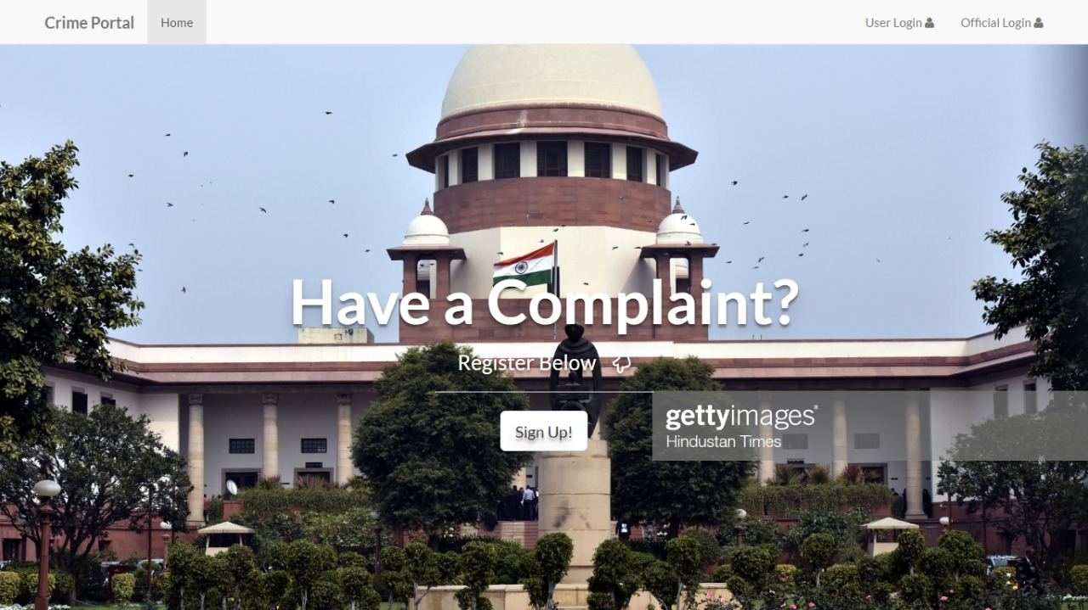

Registration:-
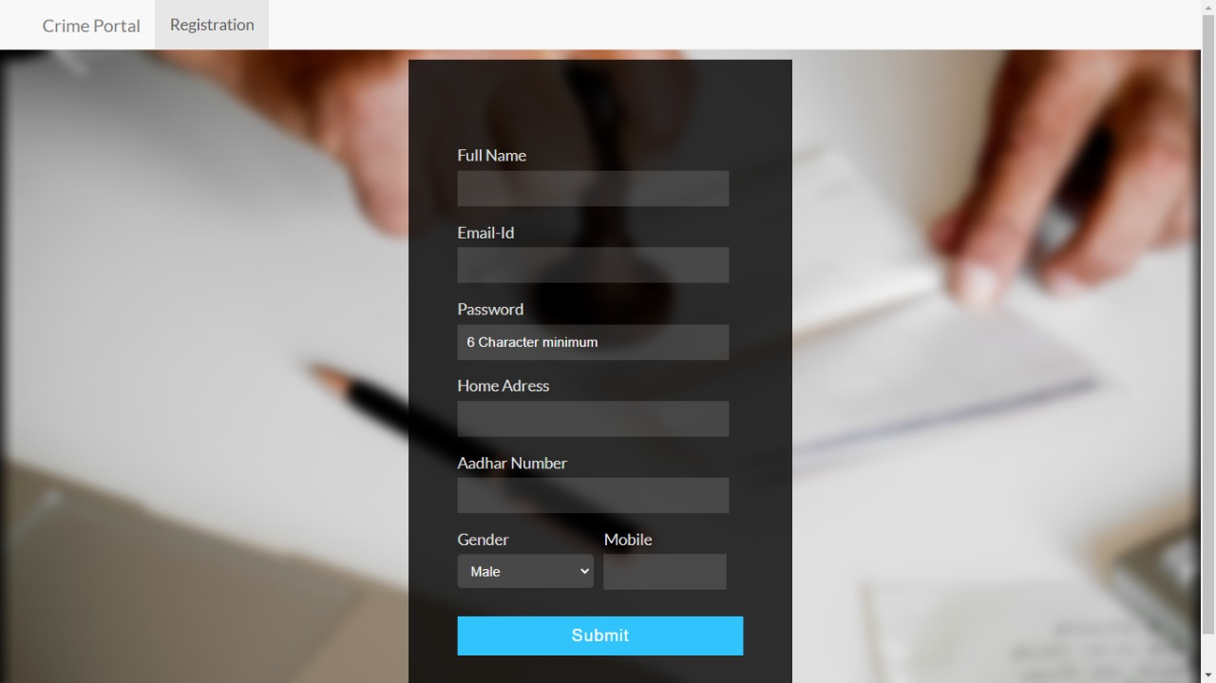

Login:-
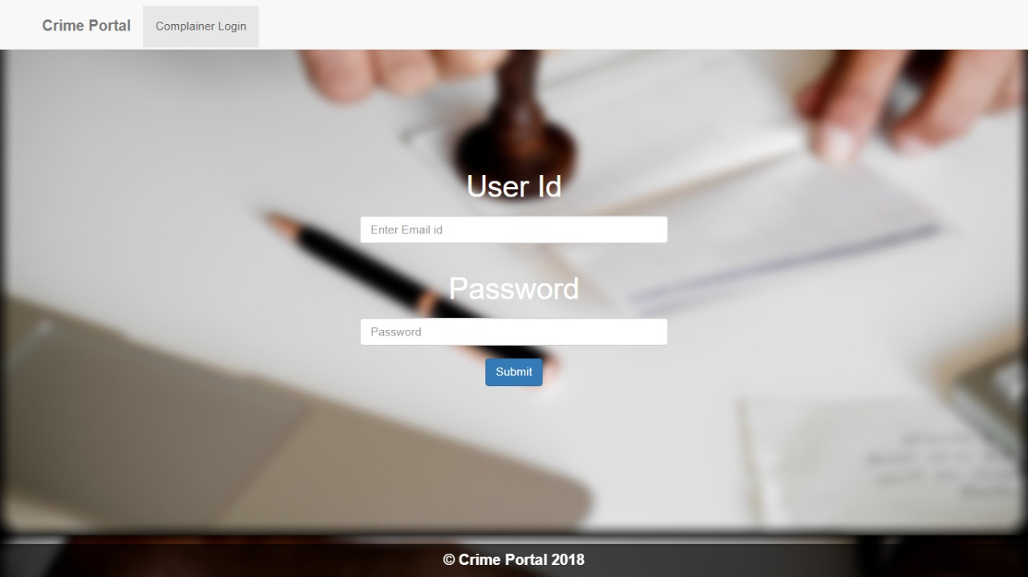

Office login:
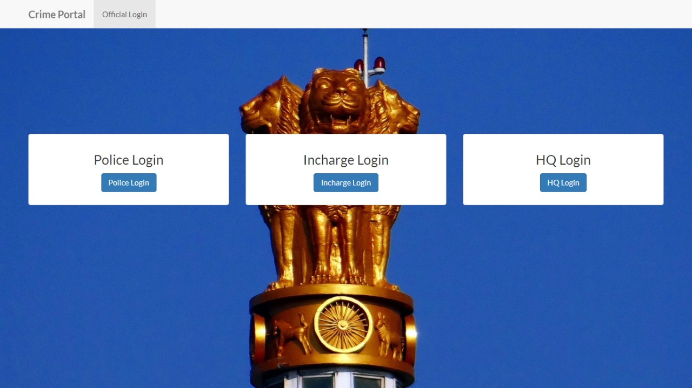-

CHAPTER-8.0
TESTING

Testing:-
• The basic goal of any software development is to produce software that has no
errors. As we know that faults can occur during any phase of software
development cycle.
• Verification is performed at output of each phase, but some faults are likely to
remain undetected and they can affect the whole Software.
• Testing relied on to detect these faults. Testing is itself an expensive activity.
• If program fails to behave as expected, it needs to debugged and corrected for that
Testing is done.
• Testing is the process of executing a program to locate an error.
• Aim of Testing → to identify all defects existing in the software product.
• There are mainly two approaches to systematically design Test Cases.
• Black Box Testing
• White Box Testing
• Black Box testing:-
• Black box testing is also known as Behavior testing, is a software
testing method in which the internal structure/design/implementation
of item being tested is not known to the tester.
• Functionality of Black box testing is understood completely in terms
of its input and output.
• Black box testing treats the software as “black box”-without any
knowledge of internal working and it only examines the fundamental
aspects of the system
White Box testing:-
• This method is concerned with testing the implementation of the
program.
• The aim of this testing is to providing the internal logic and
structure of the code. That is why white box testing is also called
structural testing.
• In white box testing it is necessary for a tester to have full knowledge of source code.
• Some of synonyms of white box testing are glass box testing, clear
box testing ,open box testing, transparent box testing, structural
testing, logic driven testing etc.
• Unit testing:-
• Unit Testing is a level of software testing where individual units/ components
of a software are tested. The purpose is to validate that each unit of the software
performs as designed. A unit is the smallest testable part of any software. It
usually has one or a few inputs and usually a single output.
Unit Testing Benefits
• Unit testing increases confidence in changing/ maintaining code.
• Codes are more reliable.
• Codes are more reusable.

➢Test Cases:-
Register
• This test case checks whether user client is able to register
Description of test case | Client will register itself
Pre-condition | Project is running
Expected Result | OK
Pass/Fail Criteria | Pass when OK faile when other

Login
• Input:-Username, Password
Input | Expected output | Actual Output
Username | Check validation | Password was  Missing
Password | Check validation | Email was missing
Username and  password | Check both Correct or not | Correct or incorrect

CHAPTER-9.0
LIMITION OF THE SYSTEM

➢ Limitation:-
• Only admin and member can login this portal.
• In our applications live chat app functionality is not available.
• Visitors can only see informations like news, guidelines, crime types, emergency contacts, about us etc.

CHAPTER-10.0
FUTURE SCOPE OF THE SYSTEM

➢ Future Scope:-

- In future, system will provide mail facility to members. Members can send mail to other stations.

- In future, system will provide online live chat application.

- In future, system will provide facility to send message related to crime to the peoples.

CHAPTER-11.0
REFERENCES

❖ Reference:-
- www.w3schools.com
- www.crime.com
- www.newsfast.tv

